**A Project Report on**

**KRISHAK:THE CROP RECOMMENDATION WEBAPP(ML)**

**By**

**Aditi Yadav(19CS04),**

**Ashutosh Awasthi(19CS16),**

**Pankaj Gangwar(19CS38),**

**&**

**Sakshi (19CS50)**

**CS-403P Major Project Lab**

**Under the guidance of**

**Dr. Anil Kumar Bisht**



**INSTITUTE OF ENGINEERING & TECHNOLOGY**

**M.J.P. ROHILKHAND UNIVERSITY, BAREILLY**

**2022-2023**

**ACKNOWLEDGEMENT**

We are extremely grateful and remain indebted to our guide **Dr. Anil Kumar Bisht** for being a source of inspiration and for his constant support in the Design, Implementation and Evaluation of our minor project. We are thankful to them for their constant constructive criticism and invaluable suggestions, which benefited us a lot while developing **“KRISHAK: A CROP RECOMMENDATION SYSTEM”.** They have been a constant source of inspiration and motivation for hard work. They have been very co-operative throughout this project work. Through this column, it would be our utmost pleasure to express our warm thanks to them for their encouragement, co-operation and consent without which we mightn’t be able to accomplish this project.

We also express our gratitude to **Dr. S.S.Bedi** for providing us the infrastructure to carry out the project and to all staff members who were directly and indirectly instrument in enabling us to stay committed for the project.

Lastly we would like to thanks our friends, without whom valuable suggestion we cannot completed our project.

**ADITI YADAV(19CS04)**

**ASHUTOSH AWASTHI(19CS16)**

**PANKAJ GANGWAR(19CS38)**

**SAKSHI (19CS50)**

**BONAFIDE CERTIFICATE**

Certified that this project report “**Krishak: Crop Recommendation System**” is the bonafide work of “**Aditi Yadav, Ashutosh Awasthi, Pankaj Gangwar** and **Sakshi**” who carried out the project work under my supervision at the university campus in session 2022-2023.

**Signature of Supervisor**

**Dr. Anil Kumar Bisht**

**DECLARATION**

We hereby declare that the work which is being presented in the project entitled **“KRISHAK:A CROP RECOMMENDATION SYSTEM”**in partially fulfil of the 7th semester project assigned by M.J.P. Rohilkhand University, Bareilly submitted in MJPRU, Bareilly is an authentic record of our work carry out the under guidance of **Dr. Anil Kumar Bisht** project in charge of MJPRU, Bareilly.

We have not submitted the matter embodied in this project for the award of any other degree.

**ADITI YADAV(19CS04)**

**ASHUTOSH AWASTHI(19CS16)**

**PANKAJ GANGWAR(19CS38)**

**SAKSHI VERMA(19CS50)**

**TABLE OF CONTENTS**

**ABSTRACT………………………………………………**

1. **INTRODUCTION………………………………………7**
2. **LITERATURE REVIEW……………………………….8**
3. **TECHNOLOGIES USED……………………………..9**
4. **METHODOLOGY………………………………………11**
5. **RESULT & ANALYSIS……………………………....15**
6. **CONCLUSION………………………………………….17**
7. **FUTURE WORKS……………………………………..17**

**REFERENCES……………………………………………18**

**CROP RECOMMENDATION SYSTEM**

Aditi Yadav, Ashutosh Awasthi, Pankaj Gangwar and Sakshi

Institute of Engineering & Technology (MJPRU), Bareilly

Dept. CSIT

**ABSTRACT:**

The effect of climate change in India is that most of the agricultural crops are being badly affected in terms of their production over a long period of last two decades. Predicting the crop yield in advance of its harvest would help the policy makers and farmers for taking appropriate measures for marketing and storage. This project will help the farmers to know the yield of their crop before cultivating onto the agricultural field and thus help them to make the appropriate decisions. It attempts to solve the issue by building a prototype of an interactive prediction system.

Implementation of such a system with an easy-to-use web based graphic user interface and the machine learning algorithm will be carried out. The results of the prediction will be made available to the farmer. Thus, for such kind of data analytics in crop prediction, there are different techniques or algorithms, and with the help of those algorithms we can predict crop yield. Random forest algorithm is used. By analysing all these issues and problems like weather, temperature, humidity, rainfall, moisture, there is no proper solution and technologies to overcome the situation faced by us. In India, there are many ways to increase the economic growth in the field of agriculture.

Data mining is also useful for predicting crop yield production. Generally, data mining is the process of analysing data from various viewpoint and summarizing it into important information. Random forest is the most popular and powerful supervised machine learning algorithm capable of performing both classification and regression tasks, that operate by constructing a multitude of decision trees during training time and generating output of the class that is the mode of the classes (classification) or mean prediction (regression) of the individual trees.

**Keywords: Agriculture, Machine Learning, Supervised Algorithms, Crop prediction**.

**1. INTRODUCTION**

Agriculture is the backbone of the Indian economy. In India, agricultural yield basically depends on weather conditions. Rice cultivation depends on rainfall. Timely advice to predict the future crop and an analysis is to be made in order to help the farmers to choose the right crop for production.

Crop prediction is an important agricultural problem. In the past, farmers used to predict their crop from previous year yield experiences. Thus, for this kind of data analytics in crop prediction, there are different techniques or algorithms, and with the help of those algorithms we can predict crop.

Random forest algorithm and other machine learning algorithm is used. Using all these algorithms and with the help of inter-relation between them, there are growing range of applications and the role of machine learning techniques in agriculture. Since the creation of new innovative technologies and techniques the agriculture field is slowly degrading. Due to these, abundant invention people are concentrated on cultivating artificial products that are hybrid products where there leads to an unhealthy life.

Nowadays, modern people don't have awareness about the cultivation of the crops at the right time and at the right place. Because of these cultivating techniques the seasonal climatic conditions are also being changed against the fundamental assets like soil, water and air which lead to insecurity of food. By analysing all these issues and problems like weather, temperature and several factors, there is no proper solution and technologies to overcome the situation faced by us. In India, there are several ways to increase the economic growth in the field of agriculture

. There are multiple ways to increase and improve the crop yield and the quality of the crops. Data mining is also useful for predicting crop.

**OBJECTIVE**

The main objectives are

1. To use machine learning techniques to predict crop.

b. To increase the accuracy of crop yield prediction.

c. To analyse different climatic parameters (humidity, rainfall, temperature)

**2. LITERATURE REVIEW**

The following research papers were referred by our team before doing this project. While referring each of these papers we have come across various different findings that are discussed below. Each of the below entries discusses the title of the research paper, the algorithms used and a general conclusion we've drawn from that research paper.

Title: Crop Recommendation System Using Machine Learning Algorithms authored by Atharva Jadhav, Nihar Riswadkar, Pranay Jadhav and Yash Gogawale. Method Used by them were Random Forest, Decision Tree , Logistic Regression. After referring to their paper , we found that Random Forest gives the highest accuracy out of all the four algorithms (98.9 %), followed by XGBoost (98.2%). Logistic Regression gave an accuracy of 95.6% while Decision Tree gave the least accuracy at 95.3%.

Title: Crop Recommendation System to Maximize Crop Yield using Machine Learning Technique authored by Rohit Kumar Rajak, Ankit Pawar, Mitalee Pendke , Pooja Shinde, Suresh Rathod & Avinash Devare.Method Used by them were Random Forest, Naïve Bayes,Support Vector Machine, Artificial Neural Network Remark: Our work would help farmers to increase productivity in agriculture, prevent soil degradation in cultivated land, and reduce chemical use in crop production and efficient use of water resources. Our future work is aimed at an improved data set with large number of attributes and also implements yield prediction.

Title: CROP RECOMMENDATION USING MACHINE LEARNING authored by Vookanti Vani, Gunukula Sai Krishna, Gourishetty Sumanjali, Bonthala Rashmitha &Burra Raju .Method Used by them were Random Tree, Naïve Bayes, K-Nearest Neighbour, Decision Tree, XG-Boost.The prediction accuracy among the algorithms is determined and XG-Boost algorithm has the highest accuracy among other algorithms. It is used to recommend the suitable crop for the soil. The algorithms like random forest, decision tree, Naïve bayes, KNN, XG-Boost areused with the help of information the wastage of land and resource reduces. This will help the crops to produce high yield production and maintain the quality and nutritional contents in the soil.

**3. TECHNOLOGIES USED:**

**3.1 FRONT END:**

**HTML-**HTML stands for Hyper Text Markup Language. It is the standard markup language for creating Web pages**.** It describes the structure of a Web page.HTML consists of a series of elements**.** HTML elements tell the browser how to display the content**.**

**CSS-**CSS is the language we use to style an HTML document. CSS describes how HTML elements should be displayed.

**JAVASCRIPT-** JavaScript is a text-based programming language used both on the client-side and server-side that allows you to make web pages interactive.

**BOOTSTRAP-** Bootstrap is a [free, open source](https://www.techtarget.com/whatis/definition/Free-and-open-source-software-FOSS-or-free-libre-open-source-software-FLOSS) [front-end](https://www.techtarget.com/whatis/definition/front-end) development framework for the creation of websites and web apps. Designed to enable [responsive](https://www.techtarget.com/whatis/definition/responsive-design) development of [mobile-first](https://www.techtarget.com/searchmobilecomputing/definition/mobile-first) websites, Bootstrap provides a collection of syntax for template designs.

**3.2 BACKEND:**

**FLASK-** Flask is used for developing web applications using python, implemented on Werkzeug and Jinja2.

**3.3 SOFTWARE USED:**

**VS CODE-**Visual Studio Code is a code editor redefined and optimized for building and debugging modern web and cloud applications.

**GOOGLE COLAB-**Colab notebooks allow you to combine executable code and rich text in a single document, along with images, HTML, LaTeX and more.

**3.4 LIBRARERIES:**

**Numpy**-NumPy offers comprehensive mathematical functions, random number generators, linear algebra routines, Fourier transforms, and more.

**Pandas**-pandas is a fast, powerful, flexible and easy to use open source data analysis and manipulation tool, built on top of the Python programming language.

**Pickle**- Python pickle module is used for serializing and de-serializing python object structures. The process to converts any kind of python objects (list, dict, etc.) into byte streams (0s and 1s) is called pickling or serialization or flattening or marshalling. We can converts the byte stream (generated through pickling) back into python objects by a process called as unpickling.

**ScikitLearn**-Simple and efficient tools for predictive data analysis.Accessible to everybody, and reusable in various contexts.

**Tree**- treelib is created to provide an efficient implementation of tree data structure in Python.

**4. METHODOLOGY**

We developed two models based on RandomForest algorithm and Decision Tree algorithm.We divided the train and train data 4:1 ratio and 3:2 ratio for each algorithm resulting in two model for each type of algorithm .Overall we got more models.

**4.1 Flow-Diagram**

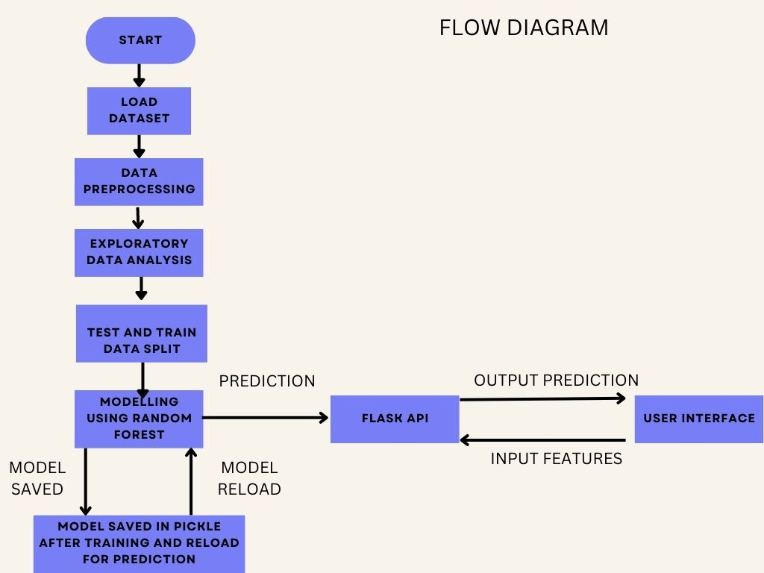

[2] Flow Diagram

**4.2 Data Acquisition**

We have taken the dataset from <https://www.kaggle.com/datasets/siddharthss/crop-recommendation-datase> It contains one .csv files

**Source**  
This dataset was build by augmenting datasets of rainfall, climate and fertilizer data available for India gathered over the period by ICFA, India.

**Data fields**  
N-ratio of Nitrogen content in soil  
P - ratio of Phosphorous content in soil  
K - ratio of Potassium content in soil  
temperature - temperature in degree Celsius  
humidity - relative humidity in %  
ph - ph value of the soil  
rainfall - rainfall in mm

COPYRIGHT: Indian Chamber of Food and Agriculture <https://www.icfa.org.in/>

**4.2 Loading dataset:**

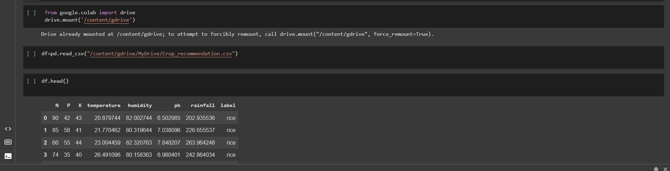

[2] Loading dataset

**4.3 Importing Libraries:**

We import different python libraries (i.e. NumPy, Pandas, Pickle) for various uses.

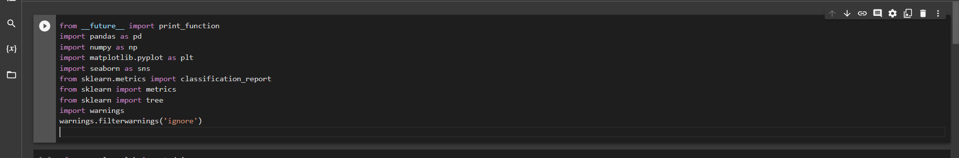

[3] Importing libraries

**4.4 Pre-processing:**

Data pre-processing is a data mining technique which is used to transform the raw data in a useful and efficient forma

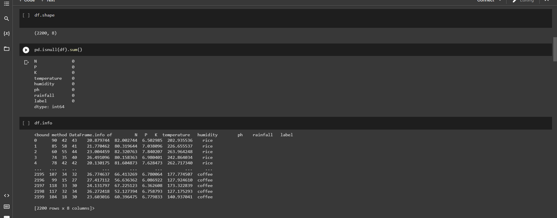

[4] Pre-processing

In data pre-processing, normalisation is very important step. Normalisation is done in order to scale the data values in a specified range (-1.0to1.0 or 0.0to1.0) 

**4.5 Splitting of data:**

Here the dataset is divided into two parts that is training data and testing data. The training data will be 80% of the total data and the testing data will be 20% of the total data. The training data contain xtrain (i.e. containing all attributes except label) and ytrain(containing label).

The testing data contain xtest(containing all attributes except label)

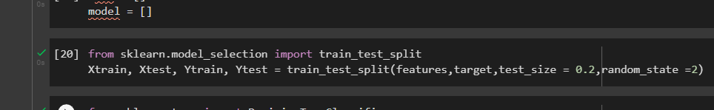

[5] Splitting dataset

**4.6 Modelling:**

Modelling of data is done by using two different machine learning algorithms that is Decision tree algorithm and Random forest algorithm.

**Decision Tree Algorithm**

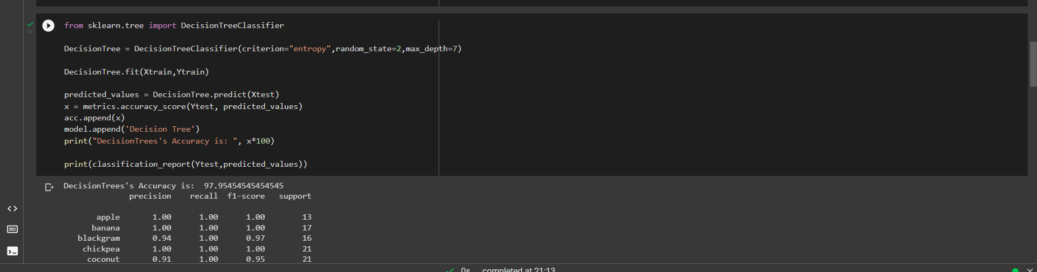

[6] Implementing Decision Tree Algorithm

**Random Forest Algorithm**

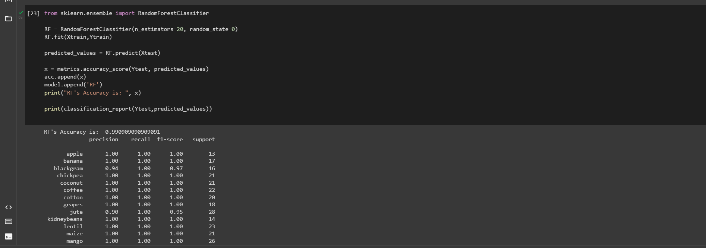

[7] Implementing Random Forest Algorithm

We have two different algorithms Decision Tree Algorithm and Random Forest algorithm for modelling out data but we have found that **the accuracy of Random Forest Algorithm is better than Decision Tree Algorithm .There we used Random Forest Model in our web application.**

**5. RESULT**

**Snapshots:**



[10] Krishak:The Crop Recommender System

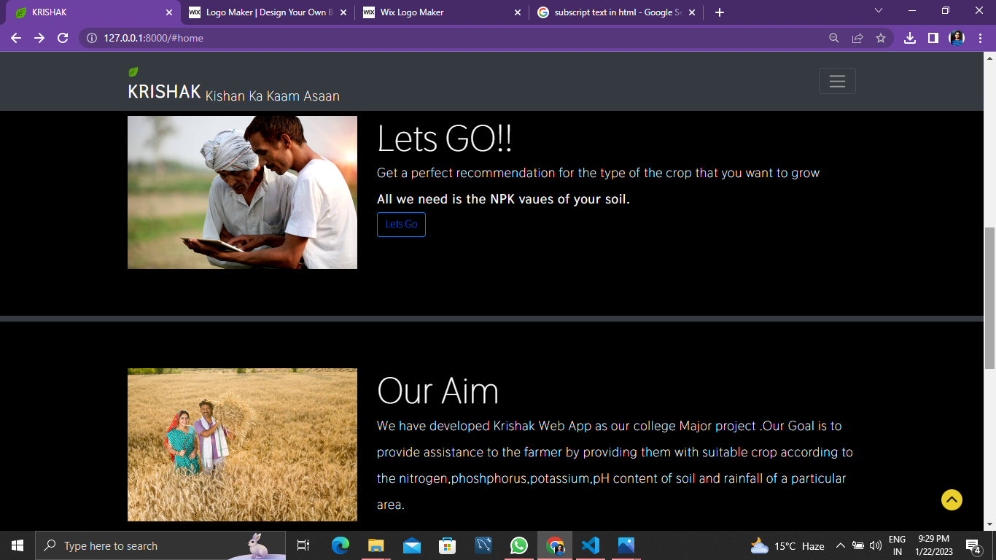

[11] Services of Krishak

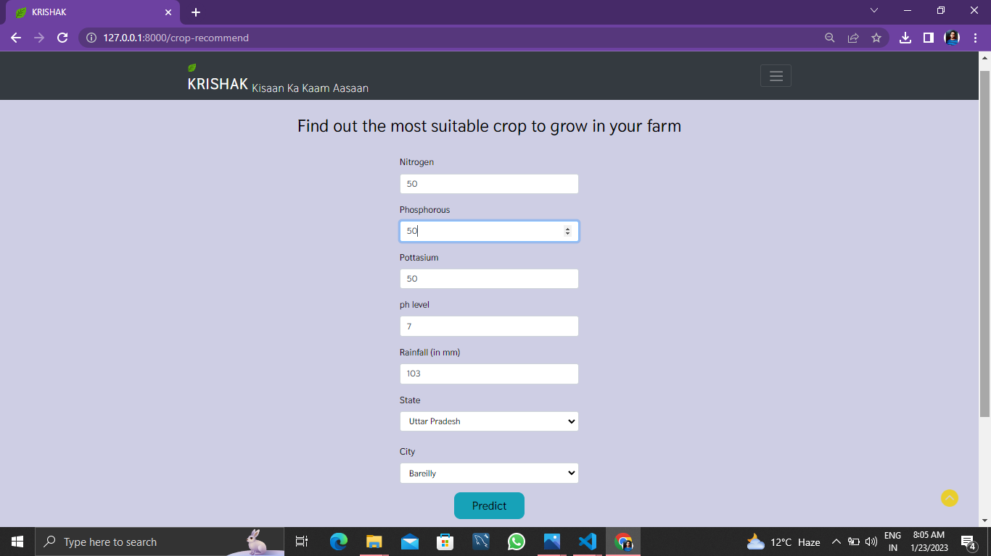

[12] Input details of soil and location

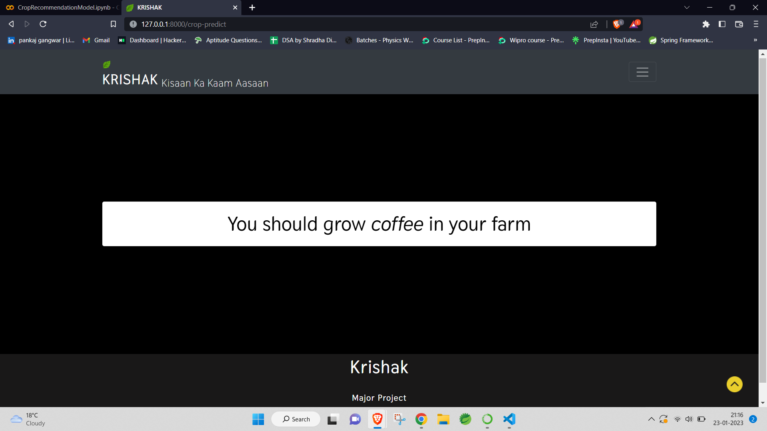

[13] Predicted Crop by system

**6. CONCLUSION**

Out of the 4 models that our team developed,we used the random forest model as it as the best effiency of 99%.However it was not the case with the decision tree classifier whose efficiency was near about 97%. The WebApplication was successful in providing the crop recommendation to the user. The use of random forest algorithm can also be justified by the fact that it has solved the problem of overfitting created by decision tree classification.

**7. FUTURE WORKS**

In Krishak:The Crop Recommender System ,the current module focuses on recommendation of crop for the farmers .As far as future is concerned we can extend it to recommend fertilisers for the crops based on the deficiency of the macro nutrients (NPK) present in the soil.

This WebApplication can also grow to other domains related to crops and plant by predicting the dieseas it has leading the developers to use image classification and providing the user with the cure of the disease.

Therefore this crop recommendor has a lot of scope to grow as fertiliser recommender and crop dieseas predictor.Two separate modules will be related for the same.

**8. REFERENCES**

[1] Babu, S. (2013). A software model for precision agriculture for small and marginal farmers. 2013 IEEE Global Humanitarian Technology Conference: South Asia Satellite (GHTC-SAS). <https://doi.org/10.1109/ghtc-sas.2013.6629944>

[2] Rajak, R. K., Pawar, A., Pendke, M., Shinde, P., & Rathod, S. (2017, December). Crop Recommendation System to Maximize Crop Yield using Machine Learning Technique. https://www.irjet.net/archives/V4/i12/IRJET-V4I12179.pdf.

[3] Mukhopadhyay, D. (n.d.). CV dr.d.mukhopadhyay. Academia.edu. <https://www.academia.edu/39528159/CV_Dr.D.Mukhopadhyay>.

[4] Savla, A., Israni, N., Dhawan, P., Mandholia, A., Bhadada, H., & Bhardwaj, S. (2015). Survey of classification algorithms for formulating yield prediction accuracy in precision agriculture. 2015 International Conference on Innovations in Information, Embedded and Communication Systems (ICIIECS). <https://doi.org/10.1109/iciiecs.2015.7193120>

[5] Shah, A., Dubey, A., Hemnani, V., Gala, D., & Kalbande, D. R. (2018). Smart farming SYSTEM: Crop Yield prediction Using regression techniques. Lecture Notes on Data Engineering and Communications Technologies, 49–56. <https://doi.org/10.1007/978-981-10-8339-6_6>

[6] Nishant, P. S., Sai Venkat, P., Avinash, B. L., & Jabber, B. (2020). Crop yield prediction based on Indian agriculture using machine learning. 2020 International Conference for Emerging Technology (INCET). <https://doi.org/10.1109/incet49848.2020.9154036>

[7] Bhosale, S. V., Thombare, R. A., Dhemey, P. G., & Chaudhari, A. N. (2018). Crop yield prediction using data analytics and hybrid approach. 2018 Fourth International Conference on Computing Communication Control and Automation (ICCUBEA). <https://doi.org/10.1109/iccubea.2018.8697806>

[8] . Bondre, Devdatta A., and Santosh Mahagaonkar. "Prediction of Crop Yield and Fertilizer Recommendation Using Machine Learning Algorithms." International Journal of Engineering Applied Sciences and Technology 4, no. 5 (2019): 371-376.

[9] . Suresh, G., A. Senthil Kumar, S. Lekashri, and R. Manikandan. "Efficient Crop Yield Recommendation System Using Machine Learning For Digital Farming." International Journal of Modern Agriculture 10, no. 1 (2021): 906-914.

[10] .Reddy, D. Anantha, Bhagyashri Dadore, and Aarti Watekar. "Crop recommendation system to maximize crop yield in ramtek region using machine learning." International Journal of Scientific Research in Science and Technology 6, no. 1 (2019): 485-489.

[11] .Pudumalar, S., E. Ramanujam, R. Harine Rajashree, C. Kavya, T. Kiruthika, and J. Nisha. "Crop recommendation system for precision agriculture." In 2016 Eighth International Conference on Advanced Computing (ICoAC), pp. 32-36. IEEE, 2017.

[12] .Garanayak, Mamata, Goutam Sahu, Sachi Nandan Mohanty, and Alok Kumar Jagadev. "Agricultural Recommendation System for Crops Using Different Machine Learning Regression Methods." International Journal of Agricultural and Environmental Information Systems (IJAEIS) 12, no. 1 (2021): 1-20.

[13] .Jejurkar Siddhi, S., S. Bhosale Meghna, and D. N. Wavhal. "Crop Predication and Diseases Detection Using Machine Learning." (2021).

[14] .Rajak, Rohit Kumar, Ankit Pawar, Mitalee Pendke, Pooja Shinde, Suresh Rathod, and Avinash Devare. "Crop recommendation system to maximize crop yield using machine learning technique." International Research Journal of Engineering and Technology 4, no. 12 (2017): 950-953.

[15] .Doshi, Zeel, Subhash Nadkarni, Rashi Agrawal, and Neepa Shah. "AgroConsultant: Intelligent Crop Recommendation System Using Machine Learning Algorithms." In 2018 Fourth International Conference on Computing